Test assignment for the java/jsf developer position at DR Australia

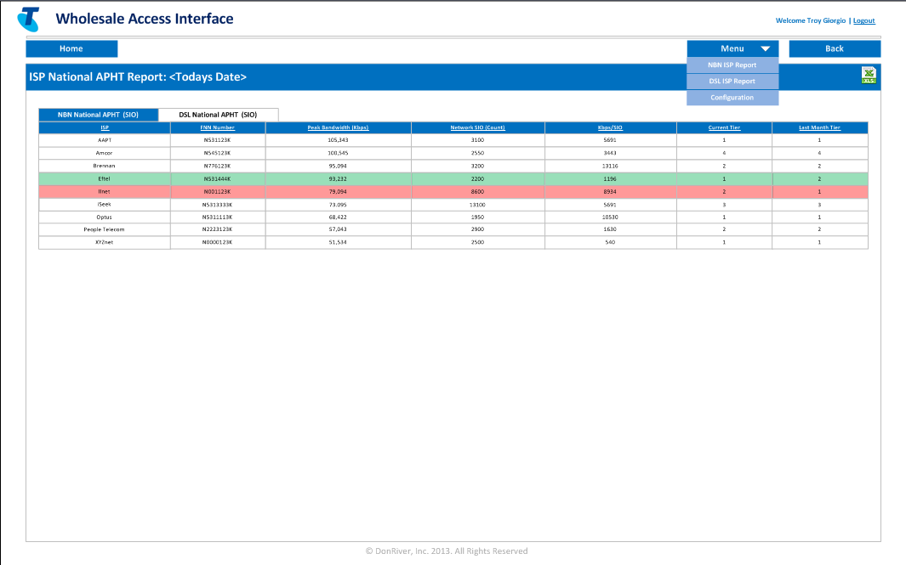

Create an Angular2 application with just one page. It should be possible to deploy the app on a Tomcat instance. Controls – PrimeNG of the latest version or any javascript control. Also please use Twitter Bootstrap. The page should have two toggable tabs. Data in the table can be selected randomly.

Functionality:

1. When the user clicks on the Logout, the app should ask if the user is OK to leave the current page and if the answer is positive the current browser tab gets closed.
2. When the user clicks on the Menu, the app should display three menu items. When an item is clicked, the app should display a confirmation message, saying that the <item name> has been activated.
3. “Home”, “Back” – do not have any handlers.
4. Data gets changed when the user toggles between tabs. The app should support highlighting of individual rows based on a column value, chose the column you like, in the following way. If the value is over 10 highlight the row in red, between 8 and 10 – green; otherwise, leave it the way it is.
5. The page should look very similar to the original screenshot

Optional:

Implement an Excel export feature so that the user can save the file on the hard drive. The default file name is ISP National APHT Report <Today >.

If you feel confident in implementing all above you can do the following:

1. Insert new button “Add…” above each of main grids – click on this button will open modal window and allows the user to add rows to each grid.
2. Add context menu for every row in a grid that will contain two items :
3. Modify row – opens new modal window that helps the user to change somehow existing row
4. Delete row – the row will be wiped out from the grid.